1) Setup jenkins CICD pipeline using freestyle job using below code.

https://github.com/betawins/hiring-app.git

Stages:

1. Git Clone

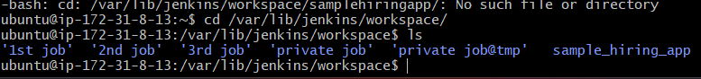

1. Sonarqube Integration



Install mysql installed and running

Sonarqube was not starting

So installed docker

1. Maven Compilation

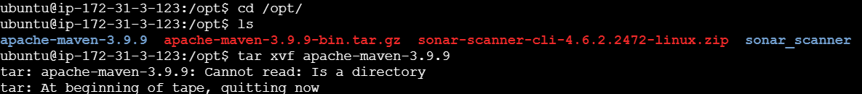

1. Nexus Artifactory

1. Slack Notification

6) Deploy On tomcat

2) Setup jenkins job using freestyle job using below code.

https://github.com/betawins/Techie_horizon_Login_app.git

Stages:

1) Git Clone

2) Sonarqube Integration

3) Maven Compilation

1. Nexus Artifactory

5) Slack Notification

1. Deploy On tomcat

